**FOOD GURU**

An Android Mobile Application Project presented to the

**Faculty of Information Technology**

School of Arts, Science, and Technology

The National Teachers College

629 J. Nepomuceno St., Quiapo Manila

By

Miranda, John Benedict M.

Brosas, Regina Carla D.

Casil, Rose Lyn S.

Barquilla, Ian Paul

Lozada, Jaimmy

Jacalne, John Bernard

Lladone, Carls V.

Balmaceda, Adrian Villaluz

In Partial Fulfillment of the

Requirements for the subject

Mobile Development focusing on Android Development

**2024**

**APPROVAL SHEET**

This Android mobile application entitled “Food Guru*” were* prepared and submitted by:

Miranda, John Benedict M.

Brosas, Regina Carla D.

Casil, Rose Lyn S.

Barquilla, Ian Paul

Lozada, Jaimmy

Jacalne, John Bernard

Lladone, Carls V.

has been approved by the subject adviser as partial fulfillment of the requirements for the subject **MOBILE DEVELOPMENT FOCUSING ON ANDROID DEVELOPMENT.**

**PROF. JOHN PAULO I. PERMINOLA**

Subject Adviser

**TABLE OF CONTENTS**

**Chapter I. PLANNING STAGE**

1.0 Introduction…………………………………………………………………..

1.1 Objective of the Study…………………………………………………….

1.2 Scope and Limitation of the Study………………………………......

1.3 Significance of the Study………………………………………………….

1.4 Requirements Gathering………………………………………………….

1.5 Visual Table of Contents Diagram………………………………….

1.6 Definition of Terms……………………………………………………….

**Chapter II. UI / UX DESIGN**

2.0 Information Architecture……………………………………………..

2.1 Wireframes…………………………………………………………………...

2.2 Prototyping………………………………………………………………….

2.3 Mockups………………………………………………………………………

**Chapter III. DEVELOPMENT**

3.1 Mobile Architecture……………………………………………………….

3.2 Project Development……………………………………………………...

3.3 Project Builds………………….……………………………………………..

3.4 Pre-Testing process…………………………………………………………

**Chapter IV. TESTING AND QA**

4.1 User Manual………………………………………………………………….

4.2 Test Cases preparation……………………………………………………

4.3 Functional Testing…………………………………………………………

4.4 Usability Testing……………………………………………………………

4.5 Performance Testing……………………………………………………...

4.6 Device Testing………………………………………………………………

**Chapter V. LAUNCH AND DEPLOYMENT**

5.1 Finalized Build………………………………………………………………

5.2 Deployment…………………………………………………………………

**Chapter VI. MARKETING AND MAINTAINANCE**

6.1 Marketing Strategy………………………………………………..........

6.2 Updates and Fixes…………………………………………………………

**Appendices**

Appendix A: References…………………………………………………………………….

Appendix B: User Testing Survey Form.…………………………………………….

Appendix C: Accomplished Survey Forms …………………………………………

Appendix D: Recommendations…………….…………………………………………..

Appendix E: Gantt Chart……………………………………………………………………

Appendix F: Roadmap……………………………………………………………………….

Appendix G: Curriculum Vitae………………………………………………………….

Appendix H: Final Assessment…………………………………………………………..

**LIST OF FIGURES**

Figure #1 ( NAME) ………………………………………………………………………………………………

Figure #2 ( NAME) ………………………………………………………………………………………………

Figure #3 ( NAME) ………………………………………………………………………………………………

Figure #4 ( NAME) ………………………………………………………………………………………………

UNTIL THE LAST FIGURE

**LIST OF TABLES**

Table #1. (NAME OF TABLE)………………………………………………………………………

Table #2. (NAME OF TABLE)………………………………………………………………………

Table #3. (NAME OF TABLE)………………………………………………………………………

Table #4. (NAME OF TABLE)………………………………………………………………………

Table #5. (NAME OF TABLE)………………………………………………………………………

**CHAPTER I**

**THE PROBLEM AND ITS BACKGROUND**

1. **Introduction**

Ever since the pandemic, people have been in their homes to further prevent the contraction of COVID. Many people during lockdown developed a lot of skills while at home, one of them is cooking. It is safe to say that people are now able to work and go out more often than they used to but cooking has always been part of their daily routine.

Sure cookbooks can be handy however, a physical one can be unmanageable to carry at all times. It can be bulky making it challenging to navigate through the recipes whenever people are out shopping for ingredients. Another problem that may arise from using the traditional cookbook is that there is a sense of difficulty in organizing and finding one’s specific recipe in a printed cookbook, it can be time consuming. Lastly, people nowadays love to reinvent anything from an object or a machine and food is no stranger. So with the mobile cookbook, customizing a recipe based on a dietary preference can provide flexibility in terms of ingredient availability and portion sizes.

So the team developed “Food Guru” a mobile cookbook that will address the issues by providing convenience and accessibility in the digital platform. Users can have their entire recipe collection with one tap of a button. Recipe navigation is easier by searching, customizing ingredient quantities and the application even provides a video cooking tutorial or demonstrations to further enhance the users cooking capabilities. The portable cookbook that comes with an interactive feature enhances the overall cooking experience for cooks as well as cooking enthusiasts at heart.

* 1. **Objective of the Mobile Application**

The developers aim to upgrade the quality of life that many people currently have by making their lives easier and making it more convenient for them in the culinary field. This will be achieved through the development of this mobile application that will serve as their portable cookbook.

* 1. **Scope and Limitation of the Mobile Application**

Anyone can cook, and anyone can benefit with the mobile application’s accessible features and innovation in the culinary field. Food Guru, the mobile cookbook aims to cater users that are aspiring cooks, those who are planning a food related business or side hustle, and upcoming chefs in the making. The application will be used mainly in a kitchen setup where utensils and other cooking tools are present.

The developers decided to use the Android Operating System for Food Guru, a mobile cookbook. They focused on using Android because it is the most flexible operating system providing accessibility and flexibility for its users. Since the main purpose of the application is to provide easy access to people’s preferred recipes and dietary preferences older versions of android such as android 8 and above will be supported.

* 1. **Significance of the Study**

The application offers comprehensive recipes and straightforward cooking instructions, making it a convenient tool for individuals passionate about preparing their favorite dishes. It provides easy access for learning and cooking, proving especially handy for daily use and appealing to those eager to explore the world of cooking.

* 1. **Requirements Gathering**
* IDE, FRAMEWORK, Programming Languages to Be Used, Database, Android Device for testing (Android version), Designing Tools.
  1. **Visual Table of Contents Diagram**

***User Accounts module***

1.5.1 User Registration - User will register its details, basic setup, and

registration

1.5.2 Profile Customization - Edit basic profile setting and information

(ex. Height and Weight).

***Meal Planning Module***

1.5.3 Automated Meal Suggestions - This feature provides users with

personalized meal suggestions based on their profile information, dietary

preferences, and activity levels.

1.5.4 Calendar sync with meals – allows users to schedule their meals on

the calendar and receive reminders.

***Video Tutorials Module***

1.5.5 Video cooking sessions – provides users with access to a collection

of video tutorials demonstrating various cooking techniques and recipes.

1.5.6 Community Chatbox - space for users to interact with each other,

share experiences, and ask questions

***Offline mode Module***

1.5.7 Offline community access – allows users to access a limited subset

of community features, such as viewing past conversations or browsing

frequently asked questions, even without an internet connection.

1.5.8 Offline Recipe editing – allows users to modify or create new recipes

even when offline.

***Grocery list module***

1.5.9 Price of each good- allows users to track the price of each ingredient

in their grocery list, helping them make informed purchasing decisions.

1.5.10 Cost Savings - helps users track their grocery expenses and identify

areas where they can potentially save money.

**1.6 Definition of terms**

* Unfamiliar terms

**CHAPTER II**

**UI/ IX DESIGN**

1. 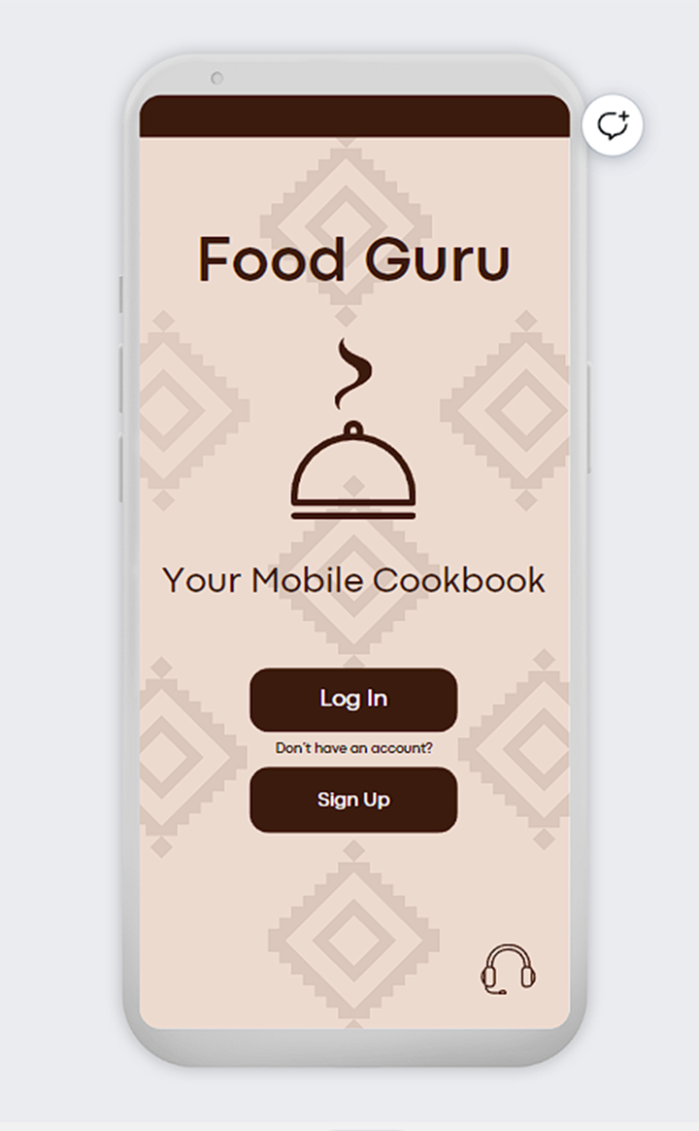

* This is the first section of the User Interface that users will be faced with once they open the application. Components of this first part of the app are; The Food Guru logo, a short description of the app, Login button and if the user wishes to register with the application they can do so by tapping on the Sign Up button. And at the bottom right corner is the icon for customer support in case there is a detected issue on the app.

1. 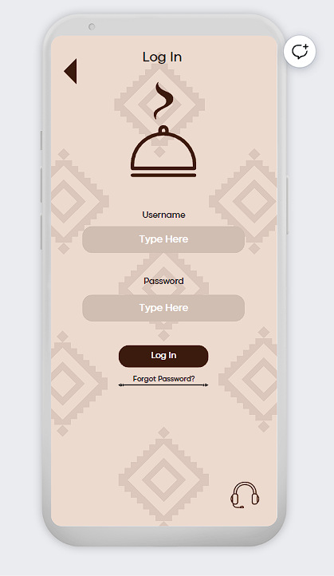

* This is the part where users with an existing account will have to fill out the username and password section of the app in order to login or gain access to their account.

1. 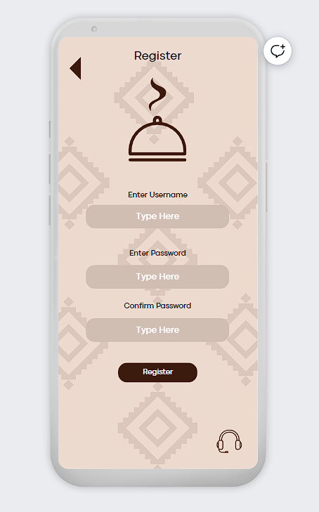

* If the user does not have an existing account, they can register and create their account by tapping on the Register button under the Login button. Users who wish to register will have to fill out their desired username (must be unique), their desired password and they will be asked to retype their password for confirmation.

1. 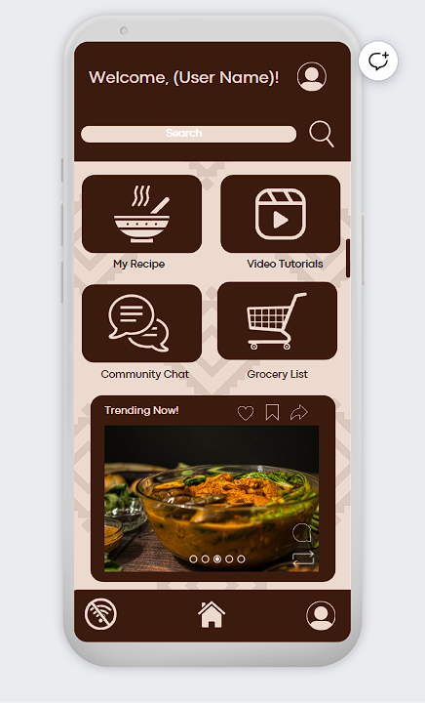

* Once logged in, users will be led to the homepage of the app where they will first be greeted. In the home section of the application, there will be four (four) buttons present; My Recipe where they can add or edit their recipes, Community Chat to help users communicate with one another and discuss culinary related topics, Video Tutorial Section where they can view and save on the device to further enhance their skills in cooking and lastly the Grocery List, this section will enable users to monitor their grocery expenses.

Aside from the buttons present on the homescreen, there is also a space where trending recipes can be seen where they can interact with by sending likes, saving the recipe and sharing it from outside of the application.

There are also three (3) buttons present at the bottom part of the application; the first one is the Offline Mode of the application so that users can still access and view their saved recipes whilst being offline. The middle button is the home button to automatically bring the users back to the homescreen and the third one is the profile button so that the user can view their profile where they can edit it to their preference.

1. 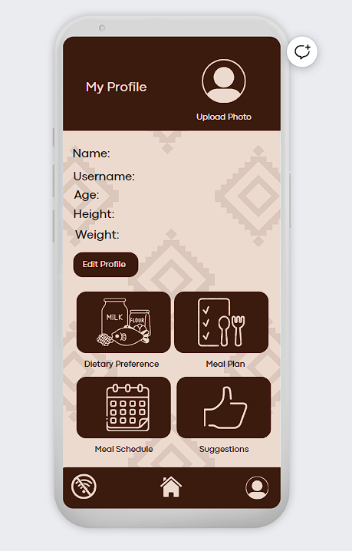

* This is the profile section of the application. In this part, users can view and edit their profile based on their preferences. This profile also showcases the basic information about them such as their; Name,Username,Age,Height and Weight all of which can also be edited by clicking on the Edit button.

Aside from the user information, there are other buttons present which are; Dietary preferences, Meal Plan, Meal Scheduling and Meal Suggestions.

**2.0 Information Architecture**

* Diagram on how the information is processed from the database to the application and vice versa.

**2.1 Wireframes**

1. 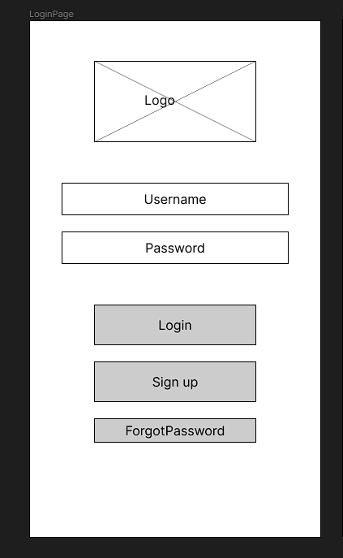

* This is the log in section of the application which has buttons for Login, Sign up, and Forgot Password in case users forget their password.

1. 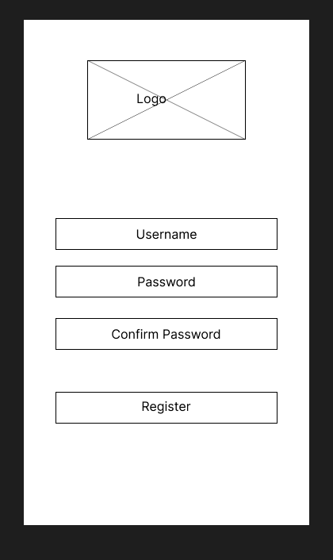

* In order to have an account in the application, users are asked to register themselves by filling out the following; Username & Password. After filling out the fields they will then tap on the Register button to create their account.

1. 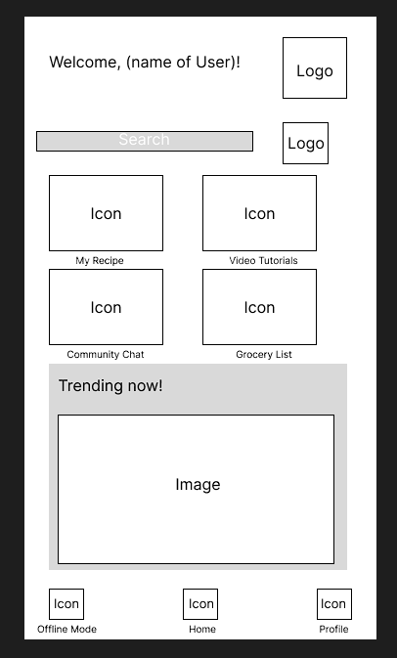

* Once logged in, users will be met with the homepage where icons for Offline Mode, Home Button and Profile buttons will be displayed. Aside from the three (3) interactive buttons present, there are also four (4) main buttons on the homepage as well. These are sections for; My Recipe, Video Tutorials, Community Chat and Grocery List. There is also a space for what current trends are ongoing in the culinary field.

1. 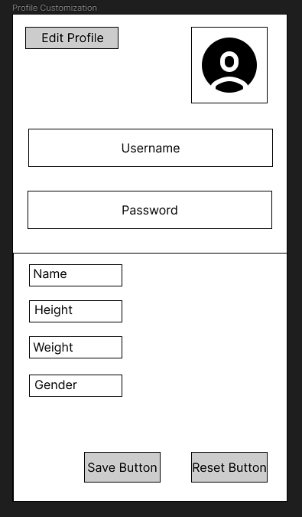

* This page is for the Profile section of the application, this is where the username as well as the user’s basic information such as their; name,height,weight and gender are visible. These can also be edited by tapping on the edit button. Once users are satisfied they can tap on the Save button to save any changes made.

**2.2 Prototyping**

* Prototyping ( Figure # and name each frame) and its process and flow.

**2.3 Mockups**

* Mock Ups ( Figure # and name each frame) and its process and flow.

**CHAPTER III**

**DEVELOPMENT**

In this chapter, the development of the application is being tracked. The mobile architecture is elaborated, and further diagrams along with discussions on important source codes are presented.

**3.1 Mobile Architecture**

- Pano naimplement yung UI nyo then , Workflow ng bawat structure at data.

**3.2 Project Development**

**-** Coding Process

**3.3 Project Builds**

- Run every build discuss the progress

**3.4 Pre-Testing process**

**-** Set testing procedures

**Chapter IV TESTING AND QA**

4.1 User Manual

4.2 Test Cases preparation

4.3 Functional Testing

4.4 Usability Testing

4.5 Performance Testing

4.6 Device Testing

**Chapter V. LAUNCH AND DEPLOYMENT**

5.1 Finalized Build

5.2 Deployment

**Chapter VI. MARKETING AND MAINTAINANCE**

6.1 Marketing Strategy

6.2 Updates and Fixes

**APPENDIX A**

**REFERENCES**

**APPENDIX B**

**USER TESTING SURVEY FORM**

**APPENDIX C**

**ACCOMPLISHED SURVEY FORMS**

**APPENDIX D**

**RECOMMENDATIONS**

**APPENDIX E**

**GANTT CHART**

**APPENDIX F**

**ROADMAP**

**APPENDIX G**

**CURRICULUM VITAE**

**APPENDIX H**

**FINAL ASSESSMENT**